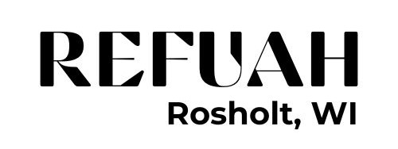
Holistic Spa Policy and Disclaimer

Reservations: Advanced booking prior to your arrival is recommended to secure your preferred date and time of treatment. Services purchased in advance will be prepaid and a Refuah wellness pass will be kept on file. We do accept walk-in guests; however, please note that availability may not be available.
Cancellation Policy: A 4-hour cancellation notice is required to help us re-schedule your appointment, subject to space availability. Any cancellation with less than 4 hours’ notice will result in a used session on wellness pass if the time slot is not filled.
Arrival: Please check in at least 10 minutes prior to your scheduled treatment to avoid reduced treatment times. A late arrival will result in a shortened treatment to accommodate other guests fairly.
Spa-Etiquette: To ensure that guests can enjoy the peaceful sanctuary at Refuah, we respectfully request that all guests keep noise to a minimum. Cellular phones and electronic devices are discouraged, please keep them on silent mode.
Pregnancy / Medical and Special-Consideration: It is your responsibility to declare any relevant medical conditions, such as; high blood pressure, heart conditions, recent surgery, are pregnant, have metal of medically implanted devices or have any other medical complications to our team before treatment, you are also advised to consult a doctor before signing up for any treatment or services. Kindly inform our team of any existing medical conditions or skin conditions. Please note that Refuah or our employee will not take any responsibilities on claims, you do so at your own risk.
Refund Policy: Services, treatment packages, spa memberships, gift certificates, spa products and merchandise purchased are non-refundable.
Payment: We accept cash and all major credit cards. Prices are subject to change without prior notice. We will do our best to keep information posted current and will honor wellness passes purchased at expired prices.
General Disclaimer: The spa treatments, services and/or facilities received or utilized at Refuah, are intended for general purposes only and are not intended to be a substitute for professional medical treatment for any condition, medical or otherwise, that Guests may have. Guests will fully indemnify and hold harmless Refuah LLC, representatives, agents, staff and suppliers, from and against all liabilities, claims, expenses, damages and losses, including legal fees (on an indemnity basis), arising out of or in connection with the spa treatments, services and/or facilities.

I have read and agree to comply with Refuah Holistic Spa policies

Name: ________________________________________________________

Date: __________________________________________________________

